History Of Python
Long ago, in 1989, a programmer named
👉 Guido van Rossum
I was working in the Netherlands.

He saw that programming languages were too difficult 😓
So, he decided to create a simple and easy language.

He started working on it during his free time 🎄(Christmas)
and after 2 years of hard work, he released Python in 1991

The name “Python” was not taken from a snake
It was inspired by a comedy show called
👉 Monty Python’s Flying Circus 😂

Today, Python is one of the most popular languages in the world 🌍
used in AI, data science, and web development,data Analysis ,TestingField,DevelopmentField,

Python History Questions

Who developed Python?
👉 Guido van Rossum

In which year did Python development start?
👉 1989

When was Python released to the public?
👉 1991 feb 20

In which country was Python created?
👉 Netherlands

Why was Python created?
👉 To make programming easy, simple, and readable

Why is Python considered an easy language?

👉 Because it has simple syntax and is easy to read and write

What problem did Python solve?

👉 It reduced the difficulty of complex programming languages

Why did Python take around 2 years to develop?

👉 For designing, testing, and fixing errors

Was Python created in a company or during free time?

👉 During free time (Christmas holidays)

- What makes Python different from other languages?

👉 Its simplicity, readability, and beginner-friendly nature

Python
Python is a general-purpose high-level programming language

OR
Python is a high-level programming language
OR

Python is an object-oriented programming language

where we can use Python language

1)For developing Desktop applications.

2)For developing web applications.

3)For developing games.

4)For machine learning.

5)For developing Artificial intelligence applications.

Features Of Python

1)Simple and easy to learn

-->Python is a programming language. When we read a python program we can feel like reading English statements.

-->The syntaxes are very simple and easy.

-->when we compare with other languages we can write programs with very less numbers.

-->we can reduce development and cost of the project

2) High-Level Programming Language

- Python is a high-level programming language.
- High-level language: A language that is easy for humans to read and write.
- Example: Python, Java, C, C++

Language

- Definition: A medium of communication between two human beings.
- Example: English, Kannada, Hindi

Programming Language
- Definition: A medium of communication between humans and machines.
- Humans write instructions in a programming language → machines execute them.
- Example: Python, Java, C, C++

Program
- Definition: A set of instructions given to a machine to perform a specific task and get a result/output.
- Example: A program to calculate the sum of two numbers.
a = 5
b = 10
print(a + b) # Output: 15

Low-Level Language

- Definition: A language that is understood directly by the machine (binary code: 0s and 1s).
- Example: Machine language, Assembly language

Machine Language
- Definition: The lowest-level language that the computer understands directly.
- Written in: Binary (0s and 1s)

Example:- 10101010 11001100

Features:
- Executed directly by the CPU
- No translator needed
- Very fast, but hard for humans to write and understand
Support: Supported by all computers (every CPU understands binary)

Assembly Language

- Definition: A slightly higher-level language than machine language, uses mnemonics (short codes) instead of binary.

Example :- MOV AX, 10
ADD AX, 20

Features:
- Easier for humans to read than machine code
- Needs an assembler to convert it into machine code
- CPU cannot run it directly
Support: ⚠ Not directly understood by CPU; needs assembler to convert to machine language
3) Dynamically Typed Language
in python we are not required to declare type of the variable,whenever we are assigning the value
based on value type will be allocated automatically,hence python is considered as dynamically typed language.

Ex:- Python ,JavaScript

syntax:--> type(var_name) or type(value) is it correct

x=10
type(x) # <class int>

y=20
type(20) # <class int>

Note Point:

If we declare the type of a variable before using it, the language is called a statically typed language.”
Ex:- java c,c++,c#

#important question

1)How does the compilation happen in python-->??


The source code has to be saved with an extension of .py format .

and this file is fed as input to the compiler where compiler checks
to the syntax and convert it into the byte code .

and this byte code is again fed as input to the interpreter and with the help of PVM it gives the required
output.

PVM--->(Python Virtual Machine) it creates a virtual environment for the execution of the code.

Note:--> compilation in python happens implicitly (internally)
4)Platform independent

Once we write a python program it can run on any platform without rewriting once again.

6)Interpreted

we are not required to compile python program explicitly,internally python interpreter will take care that
compilation.

7)IT support cross platform

it support different OS(operating system) like windows,linux,mac,ubuntu,
and internet Platform like chrome,firefox,opera mini,ucbrowser
system like HP,DeLL,Apple

8)IT supports Dynamic memory Allocation.

Once we initialize the value,immediately in the next line we can re-assign the value.

Interview Question

1)What is python and its features?

2)python is a interpreted language--> True/False

3)What is the meaning of dynamic typed language?

4)What is the difference between statically and dynamically typed language?

5)who developed Python and when it was published to the public.

6)How the compilation process happens in Python.

7)what is the difference between .py and .pyc file

Note Point:

How to check the idle path
import sys
Sys.executable

KEYWORDS

Keywords are Reserved words OR Predefined words because they have some special meaning.

1.Python keywords are case sensitive

2.In Python total 35 keywords are Present

3. we can not assign any value to the keywords

HOW TO GET ALL KEYWORDS IN GROUP FORMAT------->??

ans:----> help('keywords')
help("keywords")

Here is a list of the Python keywords. Enter any keyword to get more help.

False class from or
None continue global pass
True def if raise
and del import return
as elif in try
assert else is while
async except lambda with
await finally nonlocal yield
break for not

HOW TO GET ALL KEYWORDS IN LIST FORMAT---->??

step-->1
import keyword

step-->2
keyword.kwlist

import keyword
keyword.kwlist
['False', 'None', 'True', 'and', 'as', 'assert', 'async', 'await', 'break', 'class', 'continue', 'def', 'del', 'elif', 'else', 'except', 'finally', 'for', 'from', 'global', 'if', 'import', 'in', 'is', 'lambda', 'nonlocal', 'not', 'or', 'pass', 'raise', 'return', 'try', 'while', 'with', 'yield']

Interview Question

- What is the meaning of Keywords how many keywords is there what are the special keywords

HOW TO CHECK WHETHER GIVEN KEYWORD IS VALID OR NOT--->??

step--->1
import keyword

step-->2
keyword.iskeyword("keyword")

example:--->

import keyword
keyword.iskeyword("True")
True

keyword.iskeyword("true")
False

keyword.iskeyword("Else")
False

keyword.iskeyword("else")
True

keyword.iskeyword("python")
False

PYTHON VARIABLE

A variable is a container that holds information (data)

name = "Baby"

name → container (variable)
"Baby" → information stored

it's a name given to a memory location which holds the actual value.

A variable can holds objects of different types

All variable should be in lower case as there are more than one word in the

variable then user separates with underscore and this is called convention.

syntax:--> var_name=value

Extra Information

Snake_case

snake_case is a naming style where
- words are written in lowercase
- words are separated using underscore (_)

Example
student_name = "Rahul"
total_marks = 450

🐪 camelCase

camelCase is a naming style where
- the first word starts with lowercase
- each next word starts with a capital letter
- no spaces or underscores

Example
studentName = "Rahul"
totalMarks = 450

🏛️ PascalCase

PascalCase is a naming style where
- every word starts with a capital letter
- no spaces or underscores

StudentName = "Rahul"
TotalMarks = 450
type()
type() is used to find the data type of a variable or value.

x = 10
y = "Python"

print(type(x))
print(type(y))

id()

id() is used to find the memory address (identity) of an object.

a = 10
b = 10

print(id(a))
print(id(b))

Example

Single Variable Declaration

a = 10
name = "Prince"

Multiple Variable Declaration (Same Line)

a, b, c = 10, 20, 30

Multiple Variables – Same Value

a = b = c = 100

Dynamic Typing (No Need to Declare Type)

x = 10 # int
x = "Hello" # now string

Swapping Variables

a = 10
b = 20
print(a) #10
print(b) #20

a, b = b, a

print(a) #20
print(b) #10

Memory management in variable
----------------------------------

Explanation see the attached diagram

interview question

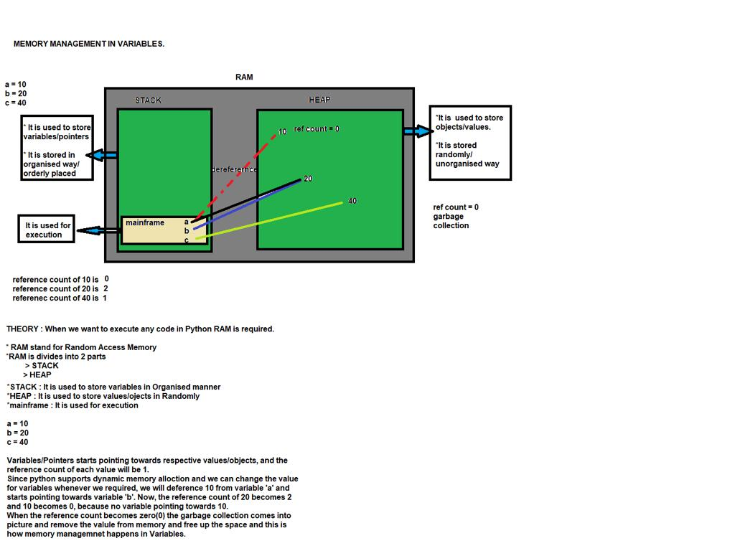

IDENTIFIERS

It is a name given to variables,function,class,modules and other objects.

OR

If you are assigning some name to a programmable entity in python then it is nothing but technically called an identifier.

Identifier Rules
_ _ _ _ _ _ _ _ _ _ _ _ _ _ _ _

Rule-->1

In identifier Part we can Pass both alphabets(upper case/Lower case)

abc=10
abc
10

ABC=10
ABC
10

a_b_c=100
a_b_c
100

ABCabc=10
ABCabc
10

Rule-->2

In identifier part we can use number but should not starts with number

Note:--> we can use number in between or last it will be working

34abc="hi"
SyntaxError: invalid decimal literal

abc34="hi"
abc34
'hi'

a3b4="hi"
a3b4
'hi'

Rule-->3

special symbol are not allowed except underscore(_)
example:-->
@=90
SyntaxError: invalid syntax

ca$h=90
SyntaxError: invalid syntax

first name="virat"
SyntaxError: invalid syntax

Rule-->4

Python documents says that you can pass an identifier with unlimited length

Note:--> maximum 79 characters

asdfghjklsdfghjhgfdssdfghjhgfdsdfghjhgfdsdfghjjhgfdsdfghjkjhgfdsdfgh=100
asdfghjklsdfghjhgfdssdfghjhgfdsdfghjhgfdsdfghjjhgfdsdfghjkjhgfdsdfgh
100

Rule:-->5
keywords can not be used in identifier part

in=89
SyntaxError: invalid syntax

if="hi"
SyntaxError: invalid syntax

elif="bye"
SyntaxError: invalid syntax

Rule:-->6

PEP-8 (Python Enhancement proposal) Document that provides guidelines and
how to practice on how to write Python code.

HOW TO CHECK WHETHER THE GIVEN PYTHON IDENTIFIER IS VALID OR NOT ??

By using below syntax

"string".isidentifier( )

"abc".isidentifier()
True

"ca$h".isidentifier()
False

"_123".isidentifier()
True

"first name".isidentifier()
False

"23456".isidentifier()
False

#note:--> here if you use a keyword it will consider a normal string not a keyword.

"in".isidentifier()
True

"elif".isidentifier()
True

Interview Question

- What is the meaning of identifier and its Rule

- What is the meaning of PEP8

- How to check whether the given identifier is valid or not

DATA TYPE
IT is a type of data which we are storing inside a variable /memory location

Types of Data Types (2)

- Single value Data Type

- Multi value Data Type

Single Value Data Type

A data type that stores only one value at a time in a variable

Types of Single Value Data Type (2)

1.Numeric Data Type

A data type used to store numbers (numeric values) in a variable.

Types Numeric Data Type

- Integer Data Type
- Float Data Type
- Complex Data Type

2.Boolean Data Type

A data type that stores only two values: True or False

Individual data type:------>

A value that is stored inside a single memory block is known as Individual data Type/single value data type

a=10

b=True

c=False

d=5.6

e=5+6j

Individual data Type classification

1.Integer data Type

2.Float data Type

3.complex data Type

4.Boolean data Type

Multivalue Data type

Here we can store More Than or More values

Types of MultiValue Data type

1 string Data type
2.List Data type
3.Tuple Data type
4.Set Data type
5.Dictionary Data type

Note Point:

Alter Native names of Single value data type

1.Individual Data type

2.Primitive Data Type

Alter Native names of Multivalue Data type

1.Collection data type
2.Iterable
3.Predefined Data type
4.Non-Primitive Data Type

String Data Type

A sequence of characters (alphabets, numbers, or special characters) enclosed within quotes.

Example

name = "Prince" # alphabets
num = "12345" # numbers as string
symbol = "@#$%" # special characters
mix = "Prince123@" # combination

Types of Quotes in String

1.single quotes
2.double quotes
3.single triple quotes
4.double triple quotes

Single Quotes ' '

For simple strings (one line)
When no special formatting is needed

Ex :- a= ‘good morning guys’
Double Quotes " "

For simple strings (one line)
Helpful when string contains single quote inside

Ex :- a= “good morning guys “

b= ‘ it’s working ‘ #error

c= “it’s working “ # no error

Triple Single Quotes ''' '''

For multi-line strings
Commenting purpose we are using

Ex ➖

msg = '''Hello
Welcome to Python
'''

print(msg)

Triple Double Quotes """ """

Same as triple single quotes

Commenting Purpose we are using

Ex::-

msg = “””Hello
Welcome to Python
“””

print(msg)

How To create empty string in normal way or by using object

#string data type Internally we can represent as an object —------> str()

1.How to check the length of the string----->?

by using len( ) function
syntax:--> len(var_name) or len(string)
2.what is the meaning of len function---->??

it will return number of characters present inside the string and it will consider space also

Example

s=”Good”

len(s) #4

len(“Good”) #4

a=” Good day”
len(a) #8

len(“Good day”) #8

#How to create the empty string data type---->??

var_name=" "

or

var_name=' '

or
var_name=''' '''

or

var_name=""" """

How to create empty string by using object

var_name=str( )

s=str() # ‘ ‘

str() # ‘ ‘

String Data type KeyPoints

- String Data type is a order datatype

- String Data type will accept duplicate characters.

Ex ➖ ‘Good AfterNooN’

